|  |  |  |  |
| --- | --- | --- | --- |
|  | **COLLEGE OF COMPUTING AND INFORMATION SCIENCES** | | |
| **Assignment # 01** | | |
| **Course Title** | Programming Fundamental | **Total Marks** | 10 |
| **Date** | 19 TO 24-11-2022 | **Class ID** | 110805(Ramzan Ali Butt) |
| **Student Id** | 65309 | **Student Name** | SOHAIB ANJUM |

**Question No. 01**

Create a page named aboutme.html that describes you. On your page include the following information:

• Your name

• А description of yourself in minimum 8 lines. Emphasize the most important word(s) by putting them in bold.

• A list of classes with id’s you are taking right now at KIET.

• Your 3 favorite movies, books, or TV shows, in order. Make at least one link to an interesting site about that tv show/movie/book, such as its IMDB page.

• Two images, one that represents you when you're happy and the other to represent you when you're sad.

• Include favorite icon.

**QUESTION 1 CODE:**

<!DOCTYPE html>

<html lang="en">

<head>

<meta charset="UTF-8">

<meta http-equiv="X-UA-Compatible" content="IE=edge">

<meta name="viewport" content="width=device-width, initial-scale=1.0">

<title>aboutme.html</title>

</head>

<body>

<div class="intro">

<h1><b><u> INTRODUCTION:</b></u></h1>

<ol>

<li>My Nameis<b><u> SOHAIB ANJUM 65309.</u></b></li>

<li>My Father Name is <b>Mian M ILYAS ANJUM</b>Son of <b>Mian M SARDAR ANJUM.</b> </li>

<li>We are <b>Four Siblings</b>and I am the <b>Third </b>one.</li>

<li>I have Done <b>Intermediate</b>in <b>Pre Engineering</b>in <b>2021.</b></li>

<li>During Intermediate I also had lounched my own Brand <b><u>CHOICE UP</u></b>on my own. </li>

<li>I am also experienced to deal with <b>International Buyers</b> And also worked with <b>AUSTRALIA,CANADA,SOUTH AFRICA,DUBAI.</b></li>

<li>I also works with Famous Brands <b>ZARA,IDEAS,SUPERBIA,A.UNIFORMS CO,ABBAS ALI AND SONS,BYCO,M&P,DANATA</b> For a time.</li>

<li>I Love to face new <b>Chalanges </b>because it's time to learn something. </li>

<li>I am currently running my own <b>buisness </b> and also completing my <b>Degree </b>in <b>KIET (BS-SE).</b> </li>

</ol></div>

<div class="course">

<h2><u><b>My Currrent Course's:</b></u></h2>

<ul >

<li><b>Programing Fundamentals(110802),</b></li>

<li><b>Programing Fundamentals LAB(110803),</b></li>

<li><b>Introductio to information Communication Tecnologies(110804),</b></li>

<li><b>Introductio to information Communication Tecnologies LAB(110805),</b></li>

<li><b>Paskistan & Islamic studies(110806), </b></li>

<li><b>Visonary Leadership & Motivation(110807),</b></li>

</ul></div>

<div class="favorites"><h2><u>My Favorites:</u></h2>

<ol><li>I love to Read book for knowledge,</li>

<li>I love to watch <b>Funny Movies </b>to get relaxes or to divert mind from stress to life.</li>

<a href="https://www.imdb.com/title/tt0903624/">Click to Watch one of my Favorite movie:</a>

</ol></div>

<div class="imotion">

<h2>HAPPY AND SAD INDICATOR</h2>

<img src="happy.jfif"width="100px" height="100px">

<img src="sad.jpg"width="100px" height="100px">

</div>

</body>

</html>

**RESULT:**

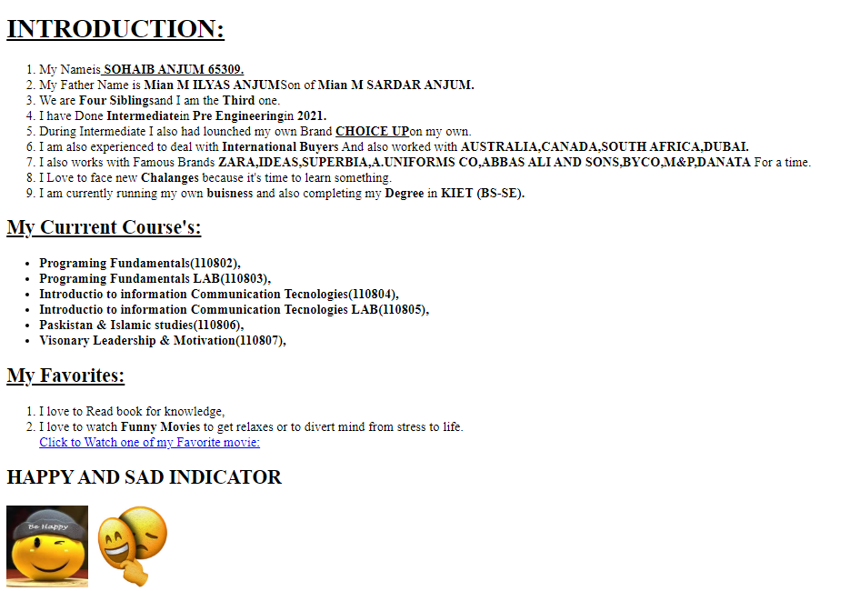

**Question No. 02:**

Create a stylesheet named aboutme-style.css to improve the appearance of your About Me page. Your stylesheet should do the following without any modification to your HTML code:

1. Change the color of at least two elements.

2. Change the font properties of at least two elements (such as family, size, weight, style).

Here are some standard fonts you may want to use: Arial, Arial Black, Verdana, Trebuchet MS, Georgia, Tahoma, Courier New, Times New Roman.

1. Change at least one other thing of your choosing (such as background color, text alignment, etc.) 2. Create border around each section of your page. There should be some gap inside and outside of each border.

• Images should be visible like in a same row.

**<HTML>CODE:**

<!DOCTYPE html>

<html lang="en">

<head>

<meta charset="UTF-8">

<meta http-equiv="X-UA-Compatible" content="IE=edge">

<meta name="viewport" content="width=device-width, initial-scale=1.0">

<link rel="stylesheet" href="style.css">

<link rel="icon" href="favicon.ico.jfif" type="image/x-icon"/>

<title>aboutme.html</title>

</head>

<body>

<div class="intro">

<h1><b><u> INTRODUCTION:</b></u></h1>

<ol>

<li>My Nameis<b><u> SOHAIB ANJUM 65309.</u></b></li>

<li>My Father Name is <b>Mian M ILYAS ANJUM</b>Son of <b>Mian M SARDAR ANJUM.</b> </li>

<li>We are <b>Four Siblings</b>and I am the <b>Third </b>one.</li>

<li>I have Done <b>Intermediate</b>in <b>Pre Engineering</b>in <b>2021.</b></li>

<li>During Intermediate I also had lounched my own Brand <b><u>CHOICE UP</u></b>on my own. </li>

<li>I am also experienced to deal with <b>International Buyers</b> And also worked with <b>AUSTRALIA,CANADA,SOUTH AFRICA,DUBAI.</b></li>

<li>I also works with Famous Brands <b>ZARA,IDEAS,SUPERBIA,A.UNIFORMS CO,ABBAS ALI AND SONS,BYCO,M&P,DANATA</b> For a time.</li>

<li>I Love to face new <b>Chalanges </b>because it's time to learn something. </li>

<li>I am currently running my own <b>buisness </b> and also completing my <b>Degree </b>in <b>KIET (BS-SE).</b> </li>

</ol></div>

<div class="course">

<h2><u><b>My Currrent Course's:</b></u></h2>

<ul >

<li><b>Programing Fundamentals(110802),</b></li>

<li><b>Programing Fundamentals LAB(110803),</b></li>

<li><b>Introductio to information Communication Tecnologies(110804),</b></li>

<li><b>Introductio to information Communication Tecnologies LAB(110805),</b></li>

<li><b>Paskistan & Islamic studies(110806), </b></li>

<li><b>Visonary Leadership & Motivation(110807),</b></li>

</ul></div>

<div class="favorites"><h2><u>My Favorites:</u></h2>

<ol><li>I love to Read book for knowledge,</li>

<li>I love to watch <b>Funny Movies </b>to get relaxes or to divert mind from stress to life.</li>

<a href="https://www.imdb.com/title/tt0903624/">Click to Watch one of my Favorite movie:</a>

</ol></div>

<div class="imotion">

<h2>HAPPY AND SAD INDICATOR</h2>

<img src="happy.jfif"width="100px" height="100px">

<img src="sad.jpg"width="100px" height="100px">

</div>

</body>

</html>

**#CODE CSS:**

body

{

background-color: white;

}

h1

{

color: rgb(248, 6, 6);

font-style: oblique;

background-color: rgba(68, 68, 67, 0.171);

border-style: solid;

border-color: rgb(234, 250, 12);

}

.intro

{

color: rgb(1, 59, 248);

font-style:italic;

font-size: x-large;

border-style:dashed;

border-color: red;

}

.course

{

color: red;

font-size:xx-large;

border-style:double;

border-color: aqua;

}

h2

{

color: brown;

}

.favorites

{

font-size:xx-large;

border-style:ridge;

border-color: blueviolet;

}

.imotion

{

text-align: center;

border-style: double;

}

**RESULT:**

